

## Course : Master of Business Administration

**Module Code & Title : PGBM156- Strategic Management in an International Context**

**Assessment : Individual Assignment**

**Title : Case Study: Managing Strategy in Covid-19 Environment**

**– Evidence from Multinational Corporations (MNCs)**

**Due Date : 29th April 2022 by 2359 hours**

**Word Length : 2000 words +/- 10%**

**Student Name & ID: Ma Pengcheng SCKL2102006**

**Supervisor :** **Dr Joachim**

**Module weighting : 100%**

**UNIVERSITY OF SUNDERLAND**

**ASSESSMENT COVER SHEET / FEEDBACK FORM**

**MBA**

Student ID: SCKL2102006

Student Name: Ma Pengcheng

Learning Outcomes Assessed:

Areas for Improvement:

Assessors Signature:

Overall Mark (subject to ratification by the assessment board)

Moderators Signature:

Students Signature: (you must sign this declaring that it is all your own work and all sources of information have been referenced)

General Comments:

Areas for Commendation:

Learning Outcomes Assessed:

Feedback relating learning outcomes assessed and assessment criteria given to students:

Mark:

Assessment Title: Individual Assignment

Module Code: PGBM 156

Module Name: Strategic Management in an International Context

Centre / College: SEGi College, Kuala Lumpur

Hand in Date:18/04/2022

Due Date: 28/04/2022

Areas for Commendation:

General Comments:

Students Signature: Ma Pengcheng

Assessors Signature:

Overall Mark (subject to ratification by the assessment board)

Moderators Signature:

Areas for Improvement:

**Executive summary**

The writing contains various factors related to the strategic management system of the organisation. The use of various models and approaches give the perfect knowledge and suggestions about the sustainable system for MNCs. In order to recover the simple and complex business problems, globalisation and localisation context and the analysis for extending business in the global market with the help of PESTLE analysis are explained here. The balance between the CSR policy and corporate profitability are also explained here thoroughly.

Table of Contents

1. Introduction 6

2. Managing Complexity in Covid-19 Environment 6

2.1 Making separation in between the simple business problem and complex business problem 6

2.2 Heavy impact of the Covid-19 on Schwarz Gruppe for sustaining in domestic and international market 6

2.3 Complexity in case of globalisation and localisation context 7

3. Management Control versus Organisational Chaos 8

3.1 Organisational context in terms of organisational development 8

3.2 Advantages and disadvantages of “organisational dynamic perspectives” and “organisational leadership perspectives” 9

3.3 Exploitation and exploration context to maximise the corporate profitability at product differentiation or low-cost leadership 10

4. Managing the paradox of Profitability and Social Responsibility 11

4.1 Paradox between CSR and corporate profitability 11

4.2 Achievement of corporate profitability and CSR in domestic and international market 12

5. Personal reflection 13

6. Conclusion 13

References 14

# 1. Introduction

Schwarz Gruppe is a very large retail company inside the UK. Generally, this company is popular for the spontaneous service system of the grocery items. This is now a multinational company. In the presence of a pandemic situation, various difficulties arise in every industry. Here, the impact of Covid-19 inside Schwarz Gruppe and the probable solutions about various crucial factors are explained here. By using important models and approaches, the probable solutions are described here thoroughly. The complexity of localization and globalization, the organisational context for the development of organisation and the paradox between CSR policy and the corporate profitability are explained here thoroughly.

# 2. Managing Complexity in Covid-19 Environment

## 2.1 Making separation in between the simple business problem and complex business problem

The simple business problem can easily sort out after the pandemic situation when the regular life has started. The lack of customers and the absence of employability are the main reasons for a simple business problem. These factors can be removed after the pandemic situation. Complex business problems arise in the absence of a proper system and investment process (Hopkinson *et al*. 2018). The use of various approaches, like in presence of supportive stakeholders, supply chains, and the production of quality products can make the entire process more spontaneous. Hence, to make more profit in the global field of business, both the complex and simple business problem should be removed. Simple business problems can be easily removed with few requirements, but complex business problems need some extra potential to become sustainable as before the pandemic situation.

## 2.2 Heavy impact of the Covid-19 on Schwarz Gruppe for sustaining in domestic and international market

Schwarz Gruppe is a multinational company, which conducts the business under Kaufland brands and Lidl. The Covid-19 became a major reason for the loss of growth rate for every small or big company. The spontaneous profit rate has decreased to a greater extent. Here, the loss of business rate in presence of Covid-19 of Schwarz Gruppe is described thoroughly.

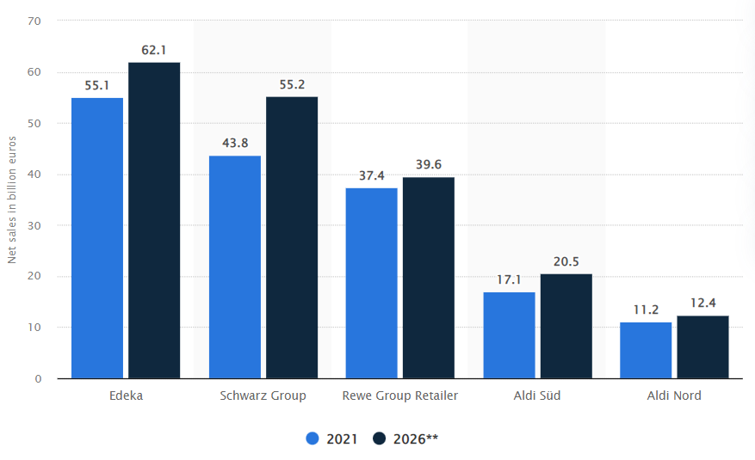

**Figure 1: Sales in billion for Schwarz Gruppe**

(Source: Statista, 2021)

In ***figure 1,*** the comparison between many companies, which are aligned with the retail industry, shows the present condition of them. From 2020, in the presence of a pandemic situation, the profitable area of every company has decreased (Statista, 2021). Both the domestic and international business field faced some difficulties to conduct the business globally. The multinational companies faced more problems and risks, as they had high investments and branching systems throughout the world. The entire business and marketing environment destroyed due to the Covid-19 situation.

After the lockdown period, every MNC focused on creating a sustainable business pattern throughout the world. The attractive offers, modification in production process, and the implementation of new products can make up the gap in domestic business areas and the standard quality of raw-materials and products, the right range of price of the products can overcome the difficulties in the international marketing field (Sovacool*et al*. 2020). The new strategy, investors, efficient team of supply chain management, and stakeholders can sort out the entire difficulties of the company.

## 2.3 Complexity in case of globalisation and localisation context

The term complexity shows the difficulties and limitations of the company towards the global marketing and business field. The concept of localisation can be raised due to the lack of a supportive customer’s chain, availability of quality raw-materials, and lack of investment process. In the presence of a pandemic situation, every company faced complexity in the localisation context. There is no way to get a sustainable process of progress. Now, after Covid-19 the situation is now almost under control (Bryson and Vanchan, 2020). The complexities of localisation context have been solved to a greater extent. The globalisation complex is like decreasing the rate of growth in the context of the global marketing field. In that case, the concept of localisation overcomes the concept of globalisation. The starting of the local level of business to proceed further and growing up throughout the world is the entire concept of globalisation and localisation. Hence, both the concepts of localisation and globalisation can be achieved easily.

# 3. Management Control versus Organisational Chaos

## 3.1 Organisational context in terms of organisational development

Organisational contexts are very necessary for the proper development of organisational development. The use of various communication skills to make the smooth way of internal and external presentations and communications. The related factors for the development of MNCs are described here. Due to the presence of ***an efficient team and team leader,*** the project can be completed at proper time (Braithwaite *et al*. 2017). The ***strong support of stakeholders*** may give the proper way of success.

**Figure 2: Organisational development factors**

(Source: Self-created)

The ***smooth and friendly behaviour of higher authority and employees*** with customers can give the extra benefits for organisational development. The modifications and ***innovation of new technology*** can save valuable time and make the products to be a better one. In order to be a reputed company, both the business problems of MNC should be overcome so that Schwarz Gruppe can have a proper position in Malaysia.

## 3.2 Advantages and disadvantages of “organisational dynamic perspectives” and “organisational leadership perspectives”

Following table shows the advantages and disadvantages of two perspectives:

|  |  |
| --- | --- |
| **Organisational leadership perspectives** | **Organisational dynamic perspectives** |
| **Advantages**   * This can give the proper bonding and communication between the team members * Very efficient for the completion work at proper time and proper guidance * Very helpful to find the strategic goals | **Advantages**   * Efficient to find the organisational strengths and resources * Motivate the employees to their works * Increase the performances of the employees |
| **Disadvantages**   * There is a high chance of conflicts and hesitation * The task suffers from limited creativity * Always make a pressure to fulfil the goals | **Disadvantages**   * This is very time consuming * This needs high range of cost * Sometimes it gives the negative impacts |

**Table 1: 3.2 Advantages and disadvantages of organisational dynamic and leadership perspective**

## 3.3 Exploitation and exploration context to maximise the corporate profitability at product differentiation or low-cost leadership

***PESTLE analysis***

|  |  |  |
| --- | --- | --- |
| **Factors** | **Description** | **Impact** |
| ***Political*** | * Parliamentary system, * Constitutional and elective monarchy system of Malaysia helpful for Schwarz Gruppe | Positive |
| ***Economical*** | * The Covid-19 slowed down the GDP rate of Malaysia (The World Bank, 2020) | Negative |
| ***Social*** | * Multicultural society may helpful for MNCs * Large population can be helpful for business | Positive |
| ***Technical*** | * Malaysia is a country of digital technology will be very helpful for any business | Positive |
| ***Legal*** | * Generally, “English common law” reflects the rules and regulations in Malaysia (Whole of Government, 2019) | Positive |
| ***Environmental*** | * Recent deforestation issues reduce the chance of business | Negative |

**Table 2: PESTLE analysis**

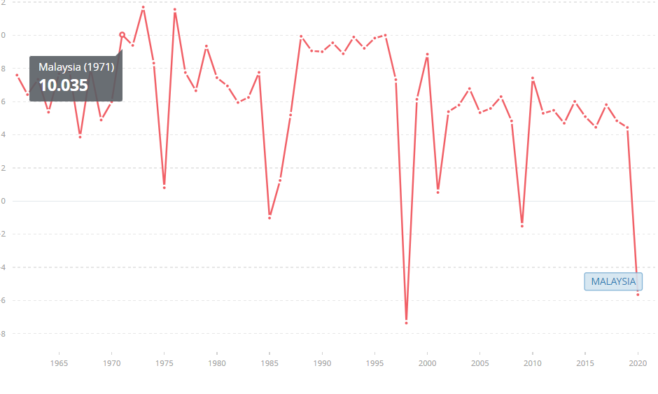

**Figure 2: GDP rate of Malaysia**

(Source: The World Bank, 2020)

The political issues of Malaysia can be very helpful for the spreading of any business smoothly. The policies and government rules and regulations are very normal and supportive for the growth of any business. The present economic condition is not good enough for the business purpose. The GDP rate of Malaysia in 2020 is -5.6, which is not suitable for sustainable business growth (The World Bank, 2020). The multicultural society and large population are another way of success for Schwarz Gruppe in Malaysia. Advanced and digital technology can give excessive results in case of progress of the company’s profit with product’s differentiation and low-price of products. The laws and regulations in Malaysia may give the proper chance to express any business in their maximum level (Whole of Government, 2019). The desertification issues in Malaysia may give the limitations and restrictions to conduct the business in Malaysia.

# 4. Managing the paradox of Profitability and Social Responsibility

## 4.1 Paradox between CSR and corporate profitability

There is a high chance of conflicts in between the corporate profitability and the CSR concept. In the case of every business, due to the use of advanced technology, and fuels from non-renewable sources, there is a high level of risks of environmental pollution. The use of various raw-materials is also very harmful for the environment. On the other hand, every company has a responsibility to make a sustainable environment to create a proper atmosphere in future. Therefore, the balance between CSR policy and corporate profitability are the main requirements for any MNCs (Lu *et al*. 2018). The higher authority of Schwarz Gruppe should focus on this topic, as this is related to the consumers. In tight environmental issues, every governmental act should focus on the sustainable environment. Hence, the governmental rules and regulation of Malaysia have some crucial acts about the CSR policies, which will be helpful to balance between the profit and environmental facts. Implementation of CSR policy can give the extra popularity towards the consumers and it will be reflected with the progress rate of the company.

## 4.2 Achievement of corporate profitability and CSR in domestic and international market

Proper guidance and rules of the government can balance the environmental issues and profitable areas of the organisation. In order to enter the international market, the positive feedback from consumers and customers are very crucial points for every MNC. The proper caring process of the environment may give a smooth relationship with consumers. Besides this, the extreme profit of any company may give the extreme carelessness towards the environment to maintain the CSR policies (Hahn *et al*. 2018). In this way, the company’s products can be rejected from the global field.

In the presence of CSR policy inside the company’s strategy, the reputations and popularity also increase to a greater extent. The use of CSR policy can increase the economic growth and reputation throughout the world. This will be very attractive and authentic to make the system more famous. On the other hand, the implementation system needs a high range of cost, which will be very difficult for any organisation (Hoffmann, 2018). This needs an efficient team of trained and experienced employees. The spontaneous campaigns are the necessary conditions for the application of CSR policy inside the MNCs.

Moreover, the application of CSR policy may give the chance to increase the mental satisfactions and make a perfect image and status of the company, which is very necessary for the global level of business and marketing field. The loyalty of customers towards the company, and the creativity of the production process and service system may be increased with the help of CSR application inside the company. In this way, both the criteria of sufficient profit and the efficient safe environment can be achieved. Hence, the corporate companies should execute and analyse the entire plans of the production and service system to make a proper system.

# 5. Personal reflection

This is a very interesting period for me to achieve the entire topic with proper guidance and efficient knowledge. Generally, at the initial stage of this lesson, this was very confusing and I was very anxious about the topic. After a few days, it became very clear and interesting to me to make proper ideas about this topic. Through this way, the crucial and key elements of organisational development are explained here thoroughly. This session gave me many important things to learn and application of these factors to make proper strategy about MNCs. in this way, I got a chance to get a clear idea about the strategic management of any organisation.

# 6. Conclusion

This writing gives a proper description about the Schwarz Gruppe’s present conditions, risks, and probable solutions to become a sustainable one. The use of different approaches and models are very useful to make a change from the impacts of pandemic situations. The impact of the Covid-19 on MNCs and the probable suggestions to make it as the sustainable one are given in this writing. The various complexities in localisation and globalisation context can be overcome with the help of this writing. The simple business and complex business problems can be sorted out in the presence of these indicated factors. The advantages and disadvantages of organisational dynamic perspectives and the organisational leadership perspectives are explained here thoroughly. The main factors for organisational development are used here. Besides this, the importance of CSR policy inside the organisation is also described here. The responsibilities of the higher authority to balance the corporate profitability and CSR policies are explained in this writing.

# References

**Journal articles**

Braithwaite, J., Herkes, J., Ludlow, K., Testa, L. and Lamprell, G., 2017. Association between organisational and workplace cultures, and patient outcomes: systematic review. *BMJ open, 7*(11), p.e017708. Available at: <https://bmjopen.bmj.com/content/7/11/e017708.abstract> [Accessed on: 05.03.2022]

Bryson, J.R. and Vanchan, V., 2020. COVID‐19 and alternative conceptualisations of value and risk in GPN research. *Journal of Economic and Human Geography, 111*(3), pp.530-542. Available at: <https://onlinelibrary.wiley.com/doi/abs/10.1111/tesg.12425> [Accessed on: 05.03.2022]

Hahn, T., Figge, F., Pinkse, J. and Preuss, L., 2018. A paradox perspective on corporate sustainability: Descriptive, instrumental, and normative aspects. *Journal of Business Ethics, 148*(2), pp.235-248. Available at: <https://link.springer.com/article/10.1007/s10551-017-3587-2> [Accessed on: 05.03.2022]

Hoffmann, J., 2018. Talking into (non) existence: Denying or constituting paradoxes of Corporate Social Responsibility. *Human Relations, 71*(5), pp.668-691.Available at: <https://journals.sagepub.com/doi/abs/10.1177/0018726717721306> [Accessed on: 05.03.2022]

Hopkinson, P., Zils, M., Hawkins, P. and Roper, S., 2018. Managing a complex global circular economy business model: opportunities and challenges. *California Management Review, 60*(3), pp.71-94. Available at: <https://journals.sagepub.com/doi/abs/10.1177/0008125618764692> [Accessed on: 05.03.2022]

Lu, W., Ye, M., Chau, K.W. and Flanagan, R., 2018. The paradoxical nexus between corporate social responsibility and sustainable financial performance: Evidence from the international construction business. *Corporate Social Responsibility and Environmental Management, 25*(5), pp.844-852.Available at: <https://onlinelibrary.wiley.com/doi/abs/10.1002/csr.1501> [Accessed on: 05.03.2022]

Sovacool, B.K., Del Rio, D.F. and Griffiths, S., 2020. Contextualizing the Covid-19 pandemic for a carbon-constrained world: Insights for sustainability transitions, energy justice, and research methodology. *Energy Research & Social Science, 68*, p.101701. Available at: <https://www.sciencedirect.com/science/article/pii/S2214629620302760>[Accessed on: 05.03.2022]

**Websites**

Statista, 2021. *Net sales of the leading grocery retailers in Germany in 2021 with a forecast for 2026 (in billion euros)*.* Available at: <https://www.statista.com/statistics/1288745/germany-leading-food-retailers-net-sales/> [Accessed on: 05.03.2022]

The World Bank, 2020. *GDP growth (annual %) – Malaysia*. Available at: <https://data.worldbank.org/indicator/NY.GDP.MKTP.KD.ZG?locations=MY> [Accessed on: 05.03.2022]

Whole of Government, 2019. *Policy, Standard, Circular and Guidelines.* Available at: <https://www.malaysia.gov.my/portal/subcategory/230> [Accessed on: 05.03.2022]